**Distance between Immune Cells and Tumor**

A step-by-step protocol

**Goals:** 1)Learn some annotation manipulation tools; 2) Learn how to quantify the distance between cells and an annotation object.

Assumes you have gone through the introductory tutorials as well as the pixel classifier example.

1. Create a new Project in QuPath 0.2.0-m6.
2. Add the files “Human Tumor CD3.czi” and “Human Tumor CK.czi” to the project. Set the Image Type to H-DAB. These are cropped images from sequential slides from a patient with cancer. One is stained for cytokeratin, which marks the tumor, while the other is stained for CD3, which marks all T cells.
3. First, load the CD3 image and perform stain deconvolution.
4. Using a small test region, optimize the parameters for Positive Cell Detection.
5. Create a Full Image Annotation using Objects > Annotations > Create full image annotation. Then, run the Positive Cell Detection on the entire image.
6. Save the cells, and then switch to the cytokeratin image. Segment the tumor by creating a pixel classifier to separate the Tumor from all other regions (Ignore). Because tumors are large, use you should use large-sigma Gaussian filtering and low resolution. Create an annotation object, set a high threshold for the minimum object size (here we used 5000 μm), and do not separate regions. Make sure the edges of the cropped region are not being seen as positive.  
     
   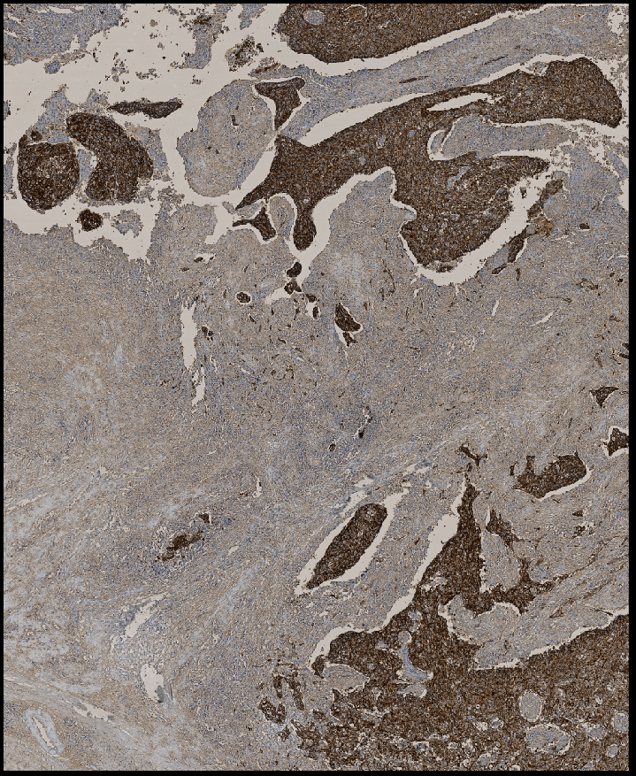 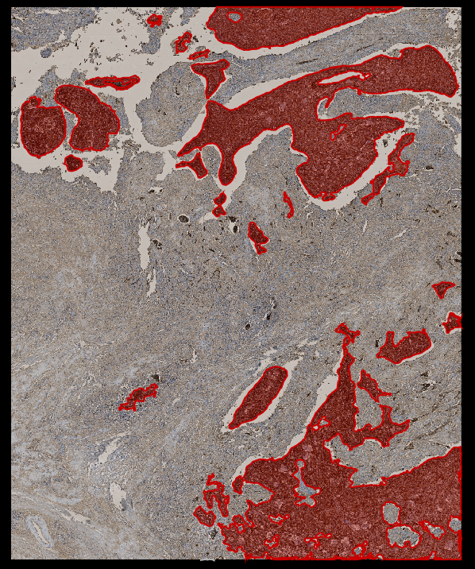
7. Select the tumor annotation, and then switch to the CD3 stained image (with saving).
8. Transfer the tumor annotation based on the cytokeratin measurement to the CD3 image by Objects > Annotations > Transfer last annotation. This will transfer whatever is the last annotation you clicked on. It will be in the exact same position as in the previous slide, which will not overlap perfectly with the same region in this slide.   
     
   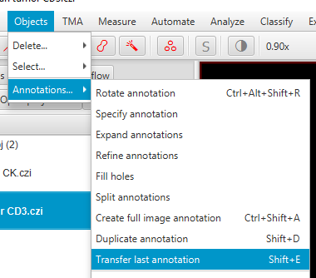 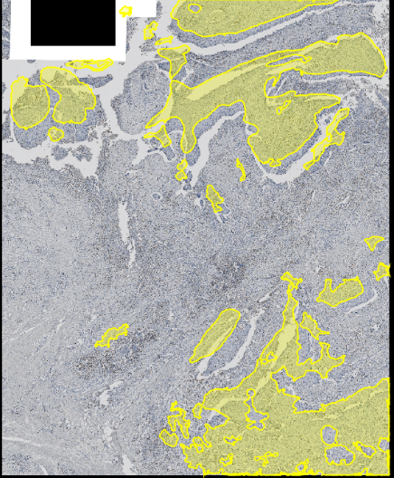
9. To realign the annotation to the CD3 slide, click on the annotation and use Objects > Annotations > Rotate annotation. This will bring up new handles that will allow you to rotate and translate the whole object until it matches the visible regions in the image. It may be helpful to hide the cell outlines while you do this, for clarity. When you are satisfied, double click outside the image to confirm your changes. Keep in mind that because these are sequential slides, the tumor outlines will not be precisely the same.   
     
   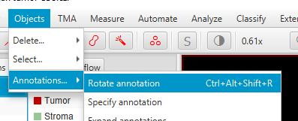 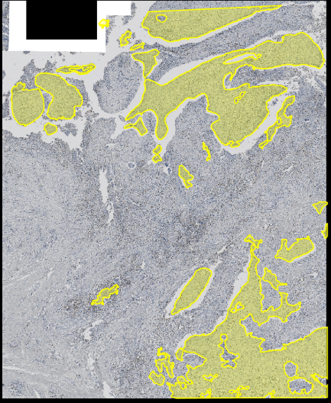
10. Select the tumor annotation, then measure the distance of every cell to that boundary using Analyze > Spatial Analysis > Distance to annotations 2D (experimental). No window will pop up when you select this, just give it some time to calculate.   
    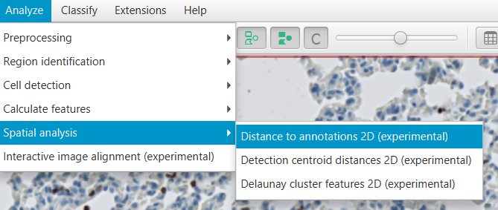
11. You can view the distance map using Measure > Show Measurement Maps. The distances of the positive and negative cells can be exported through the Detection Measurements Table. In this table, the class column shows whether the cell is CD3 positive or negative, while the Parent column shows whether it is outside of the tumor (Parent = PathAnnotationObject) or inside the tumor (Parent=Tumor).

